Data Analytics (DA)
Module-End -1

Module End Assignment:

“Data Cleaning, Analysis & Visualization with Excel”

NAME:ABINAYA MONDAL DATE OF SUBMISSION:22/07/2026 BATCH:22

ASSIGNMENT LINK:Ecommerce_Sales_Dataset_updated (6).xlsx

● Data entry, import, and basic organization using tables
SCREENSHOT-1
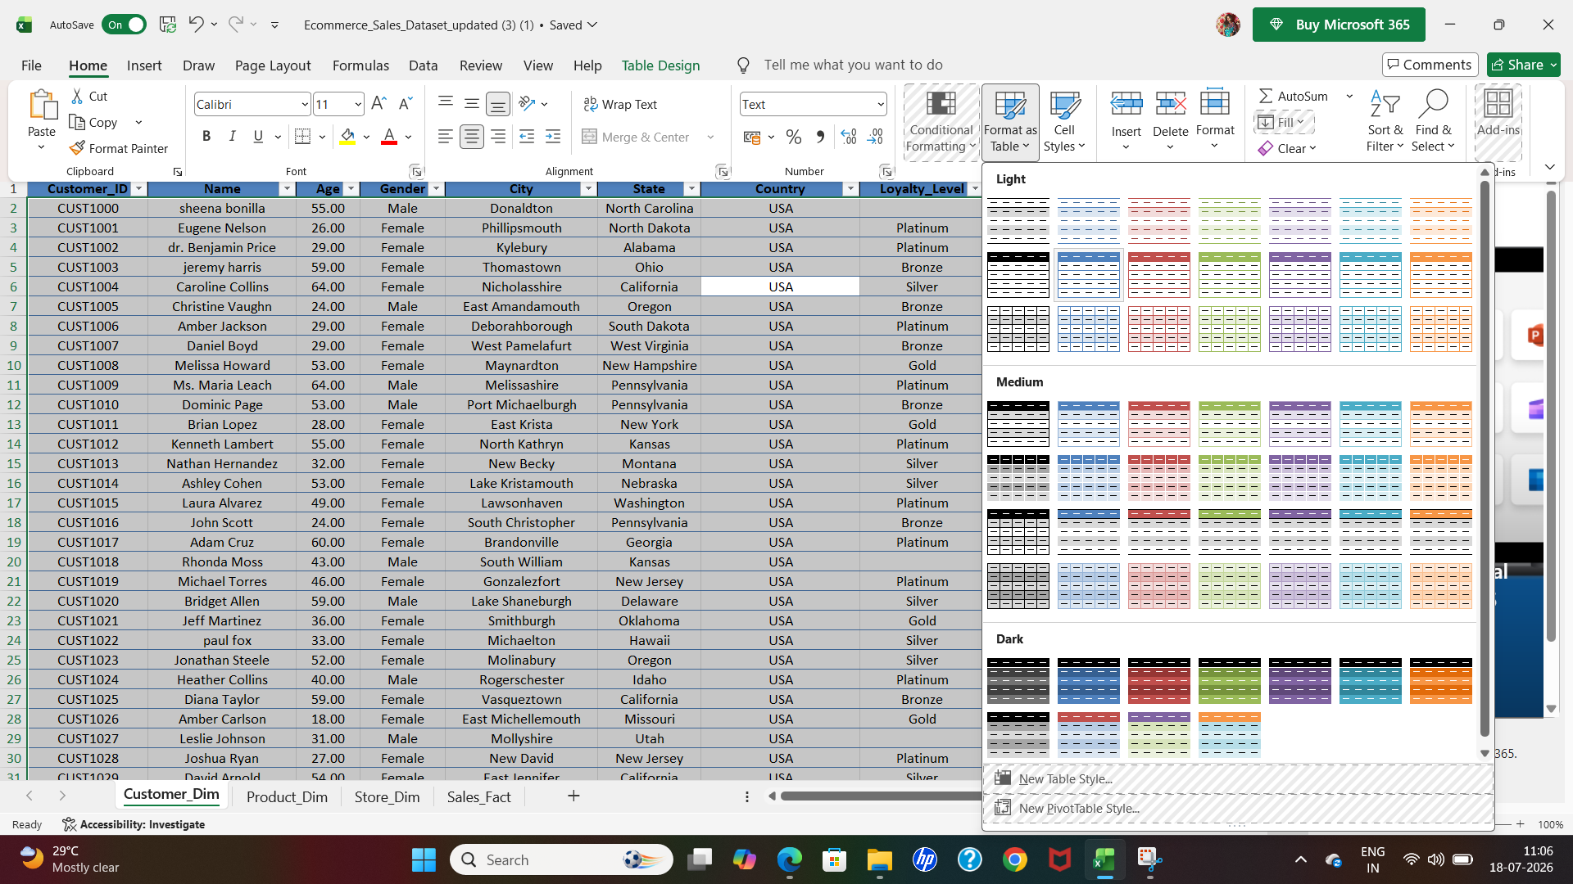

● Data cleaning: find/remove duplicates, handle missing/inconsistent data, correct
formatting errors, and validate data

SCREENSHOT-2
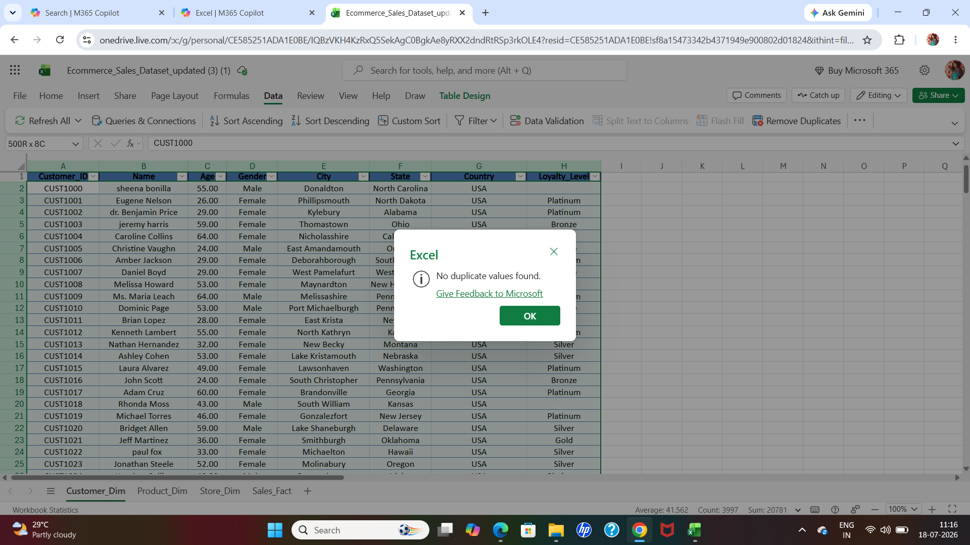
SCREENSHOT-3
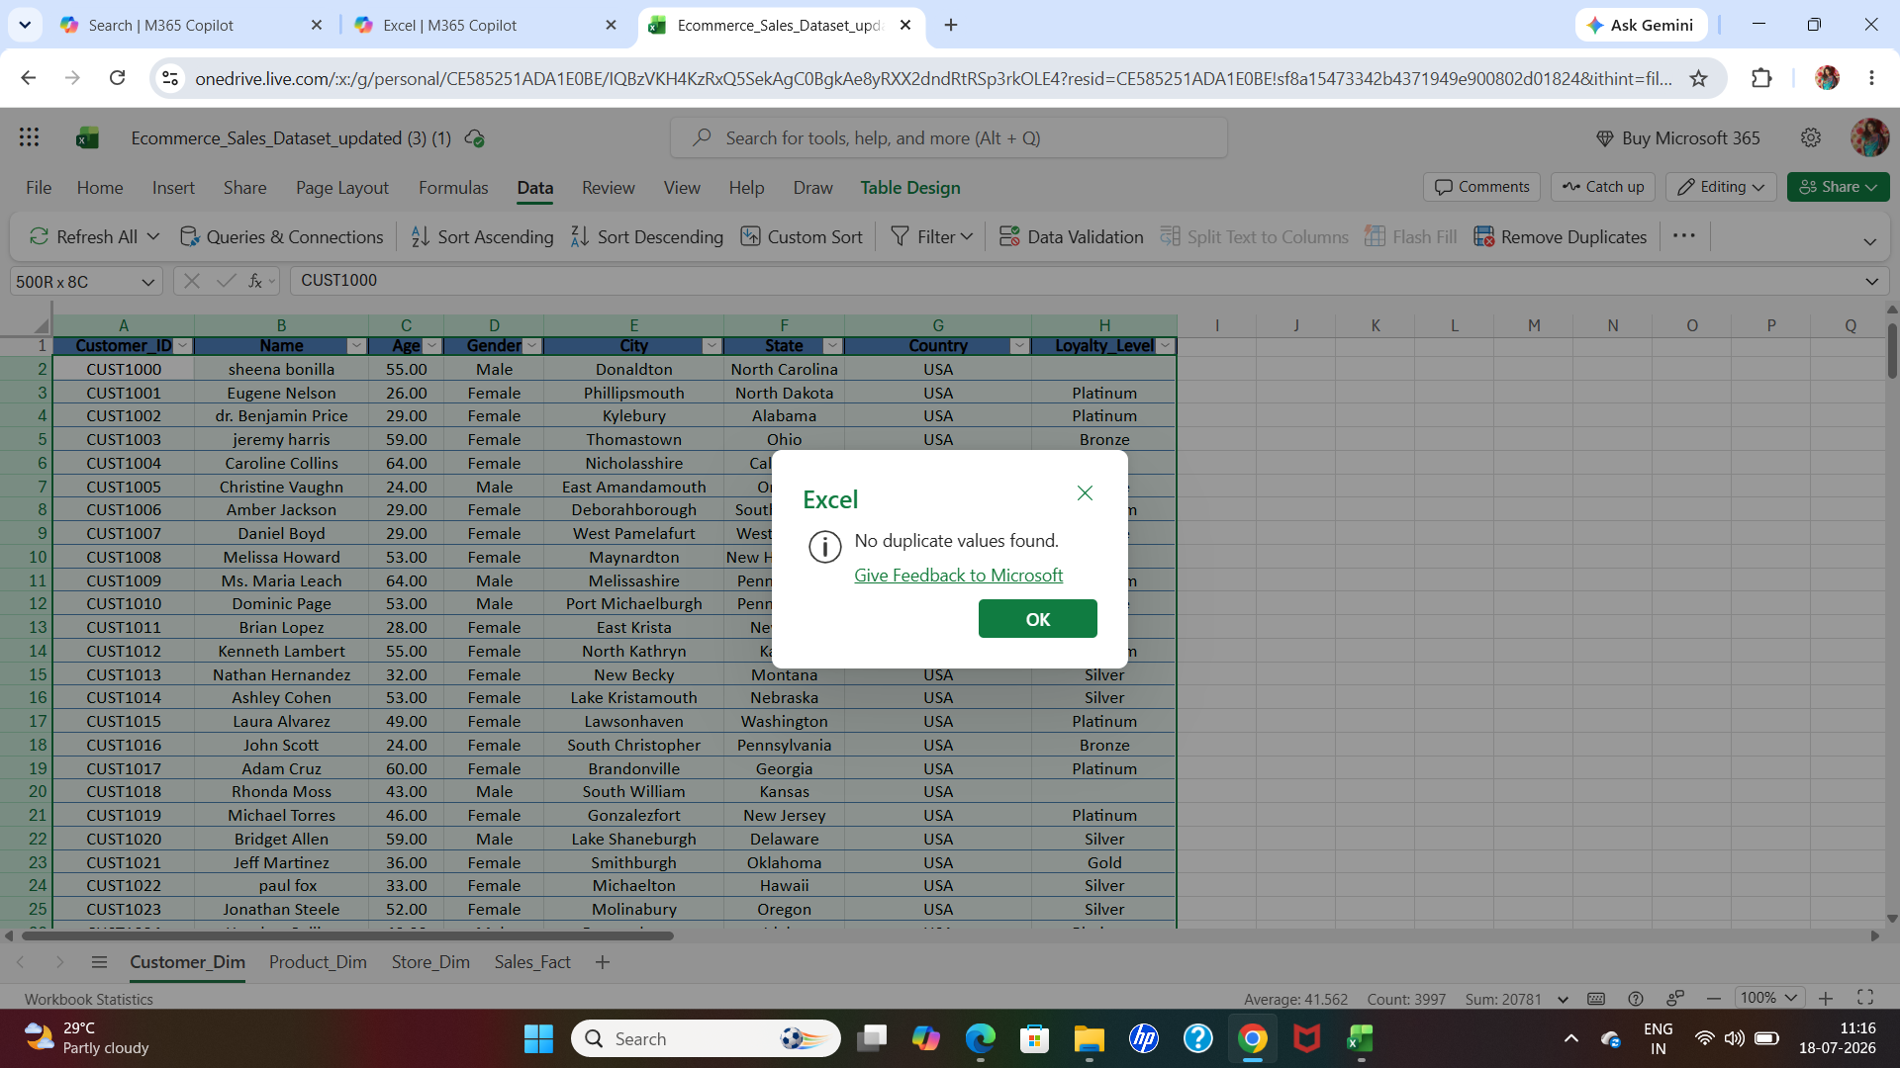

SCREENSHOT-4
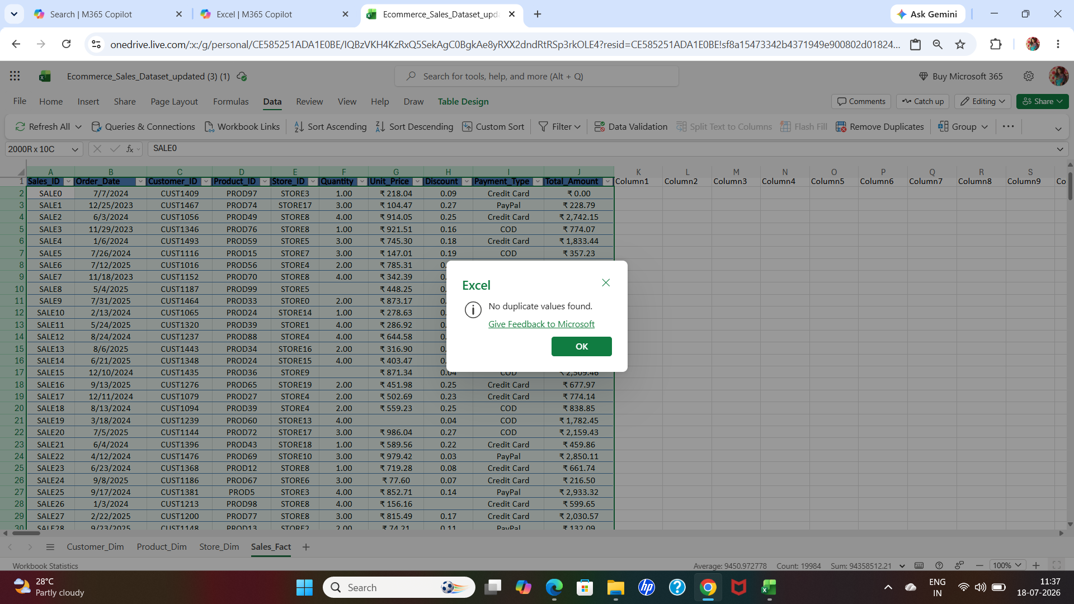
SCREENSHOT-5
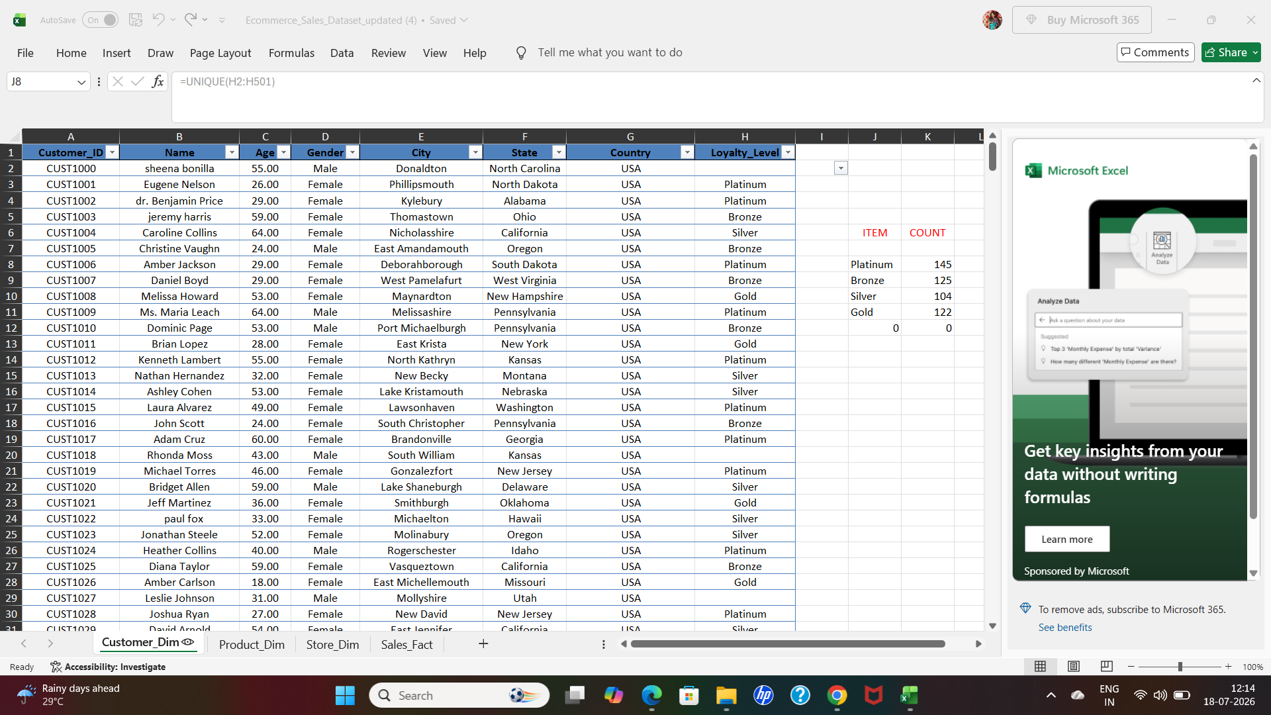

SCREENSHOT-6
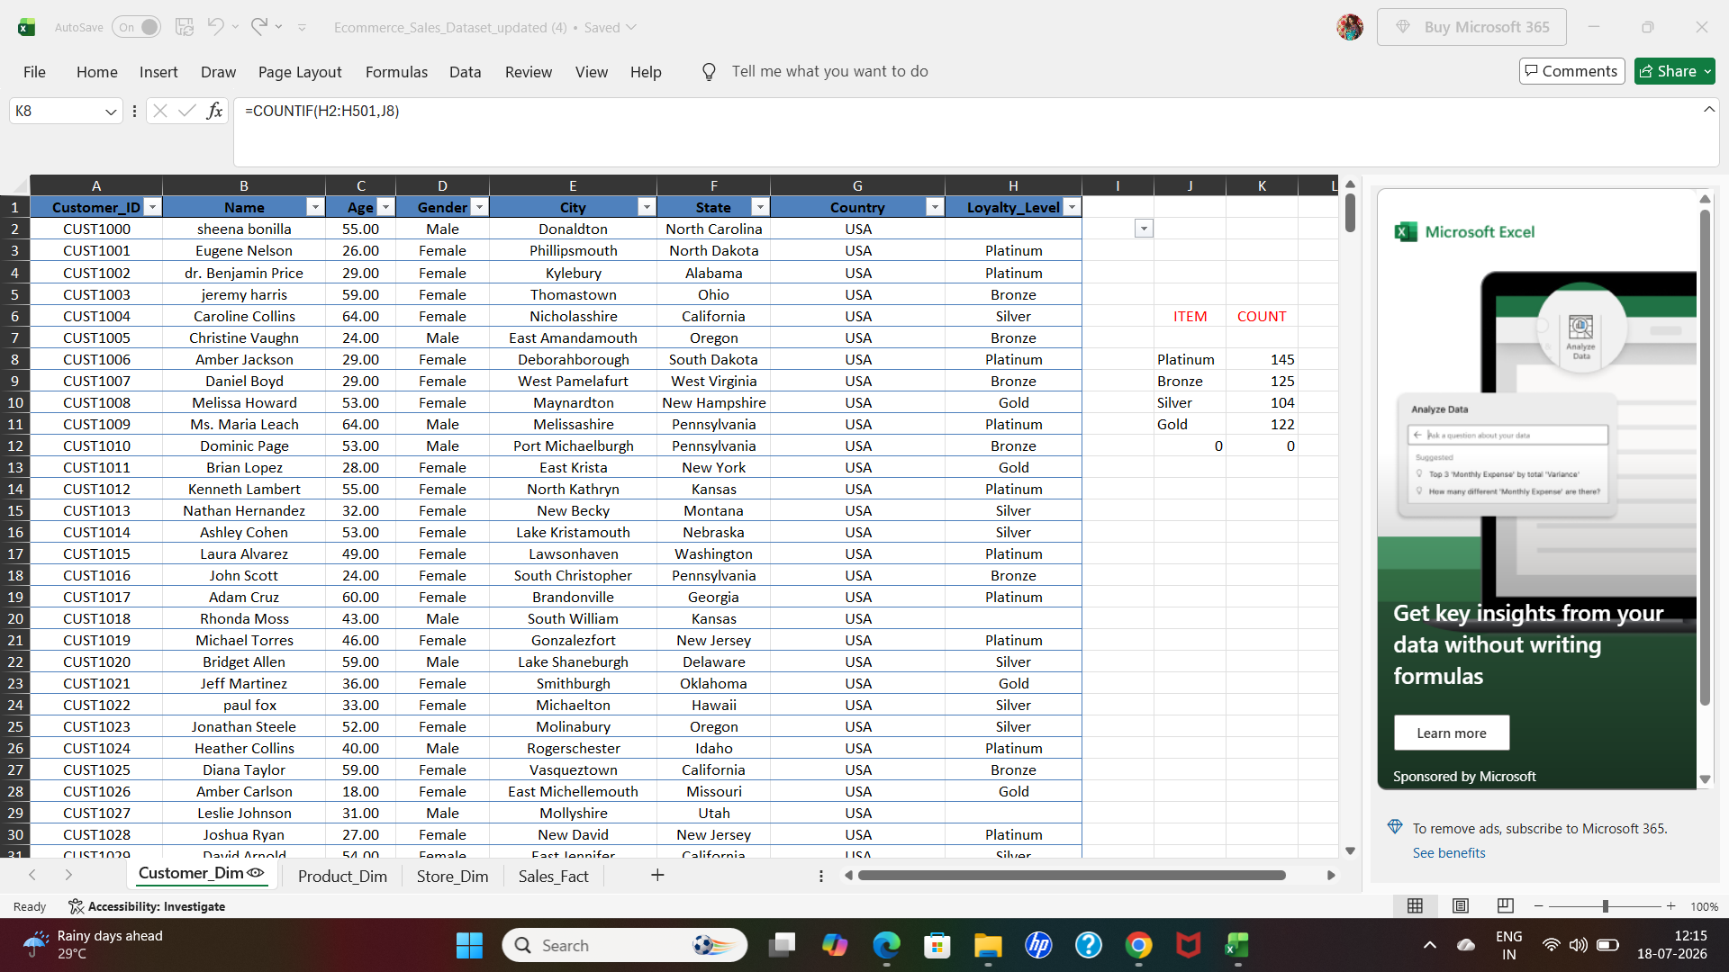
SCREENSHOT-7
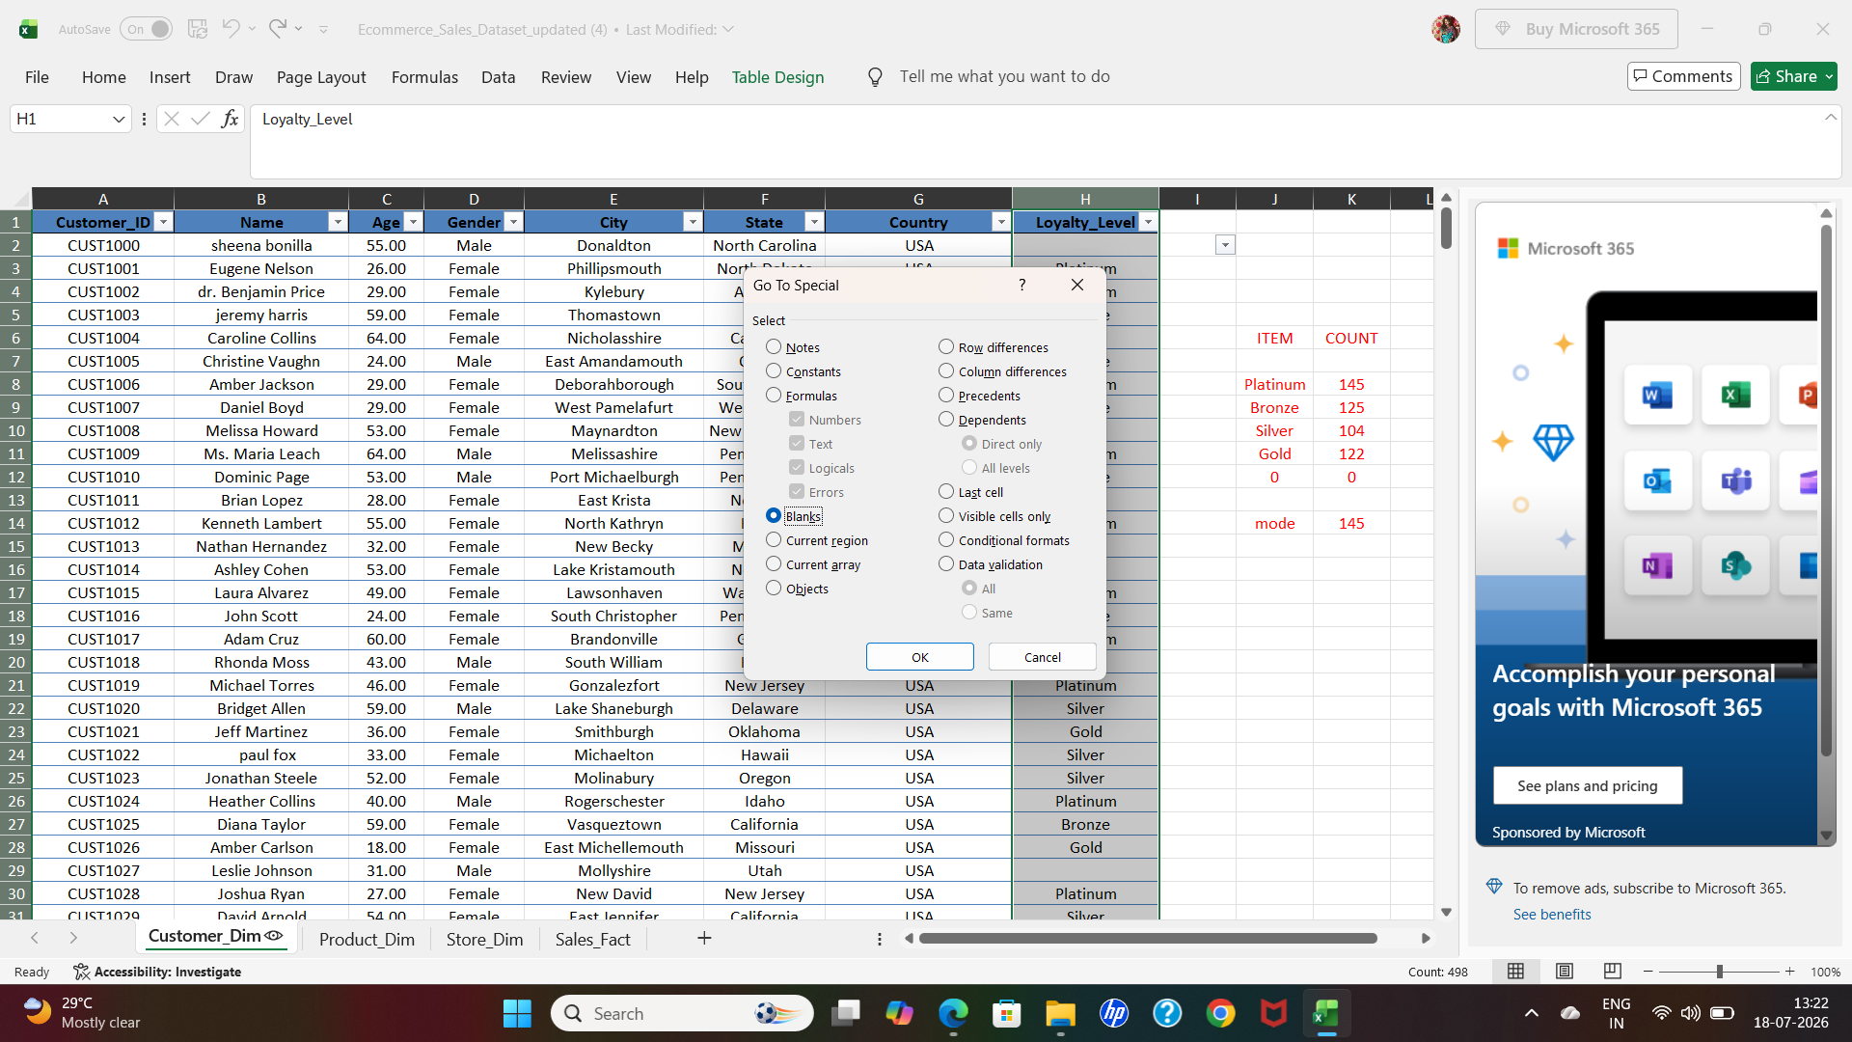

SCREENSHOT-8
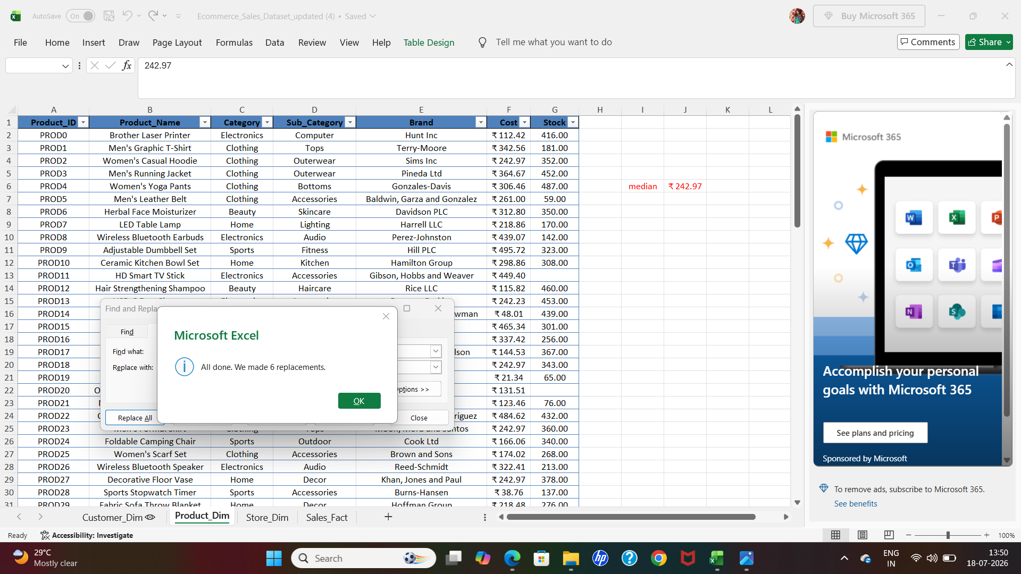
SCREENSHOT-9
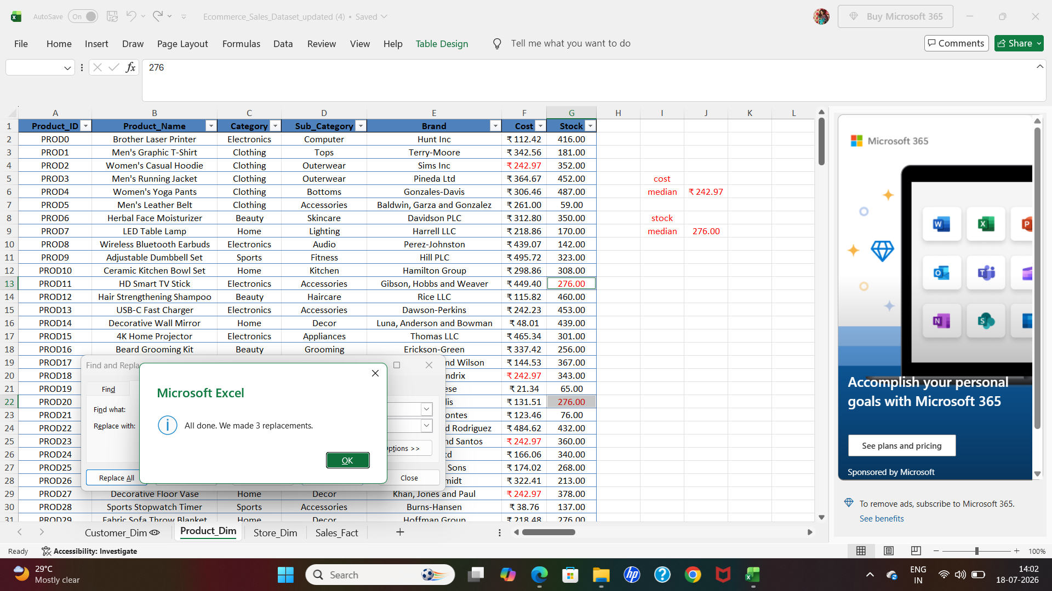

SCREENSHOT-10
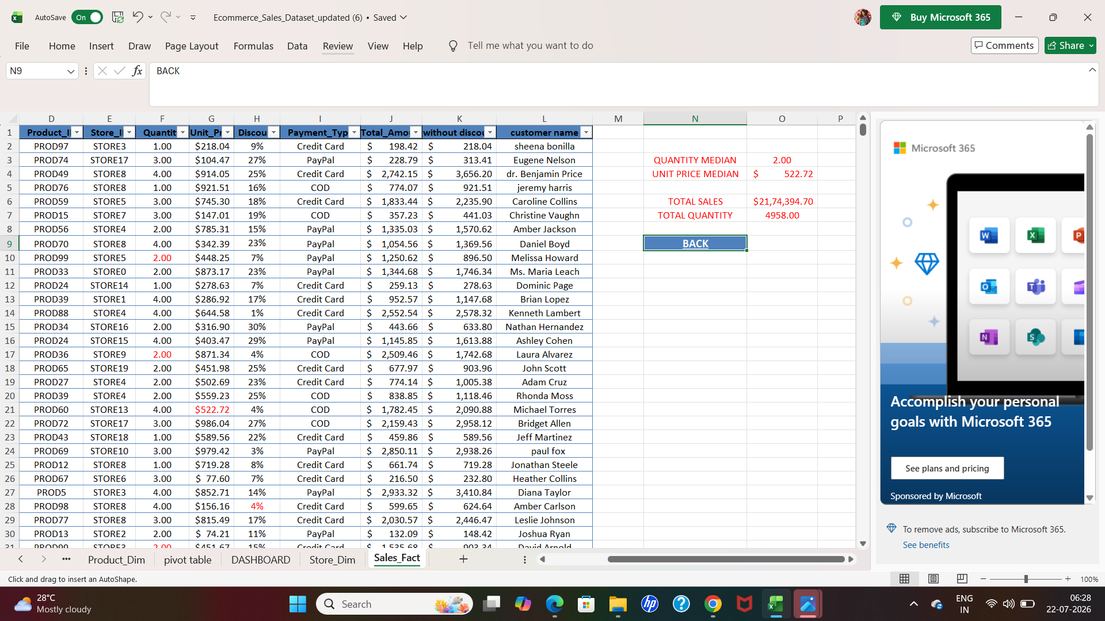
SCREENSHOT-10
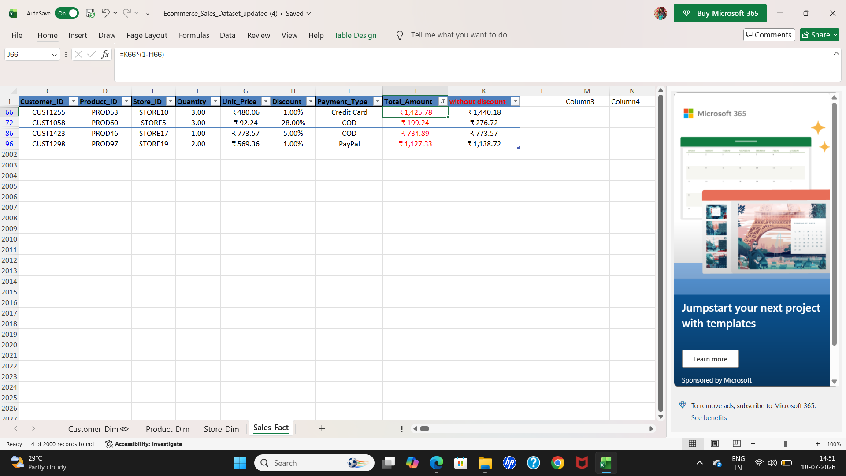

Correct formatting errors
SCREENSHOT-11
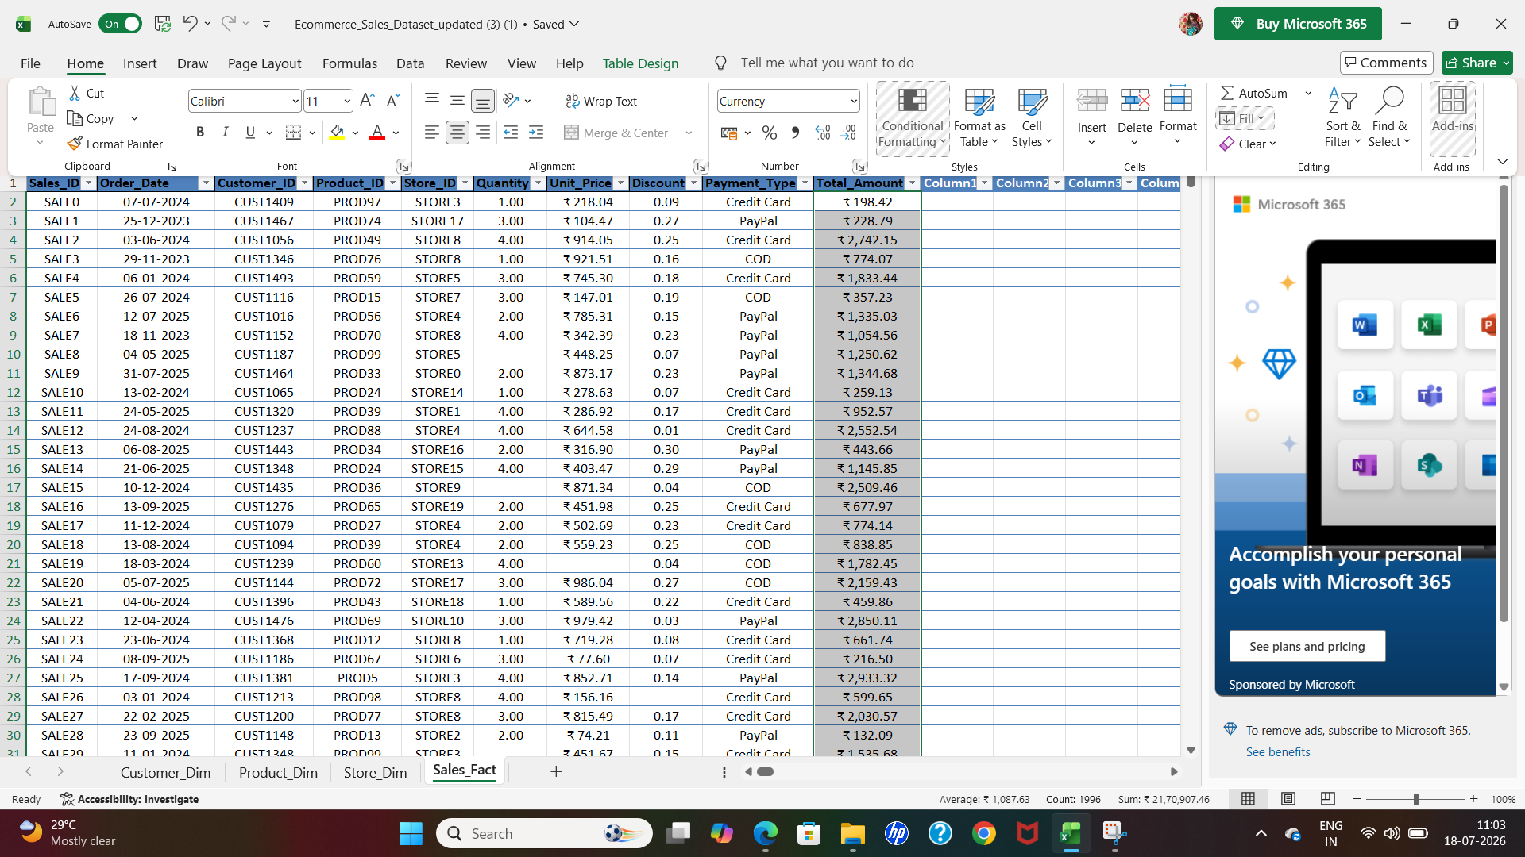
SCREENSHOT-12


● Application of Excel formulas for calculations, summaries, and logical/text operations
SCREENSHOT-13
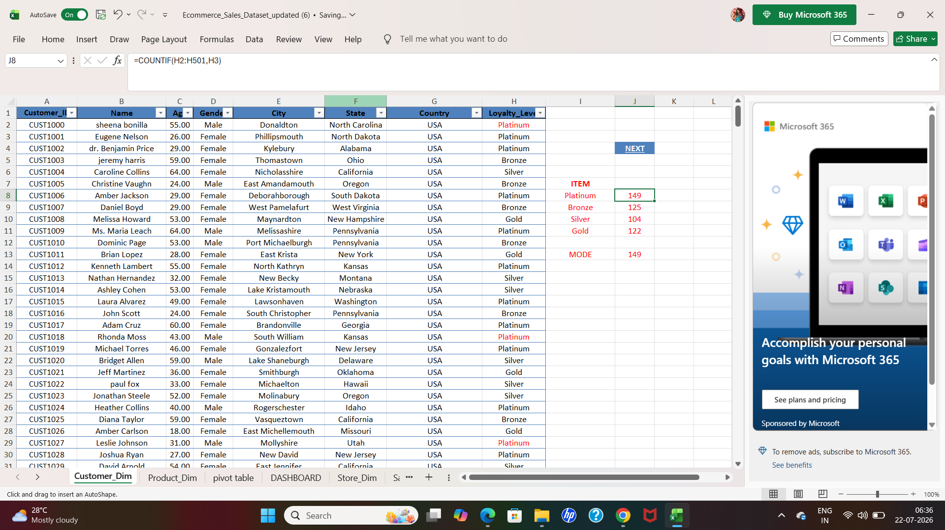
SCREENSHOT-14
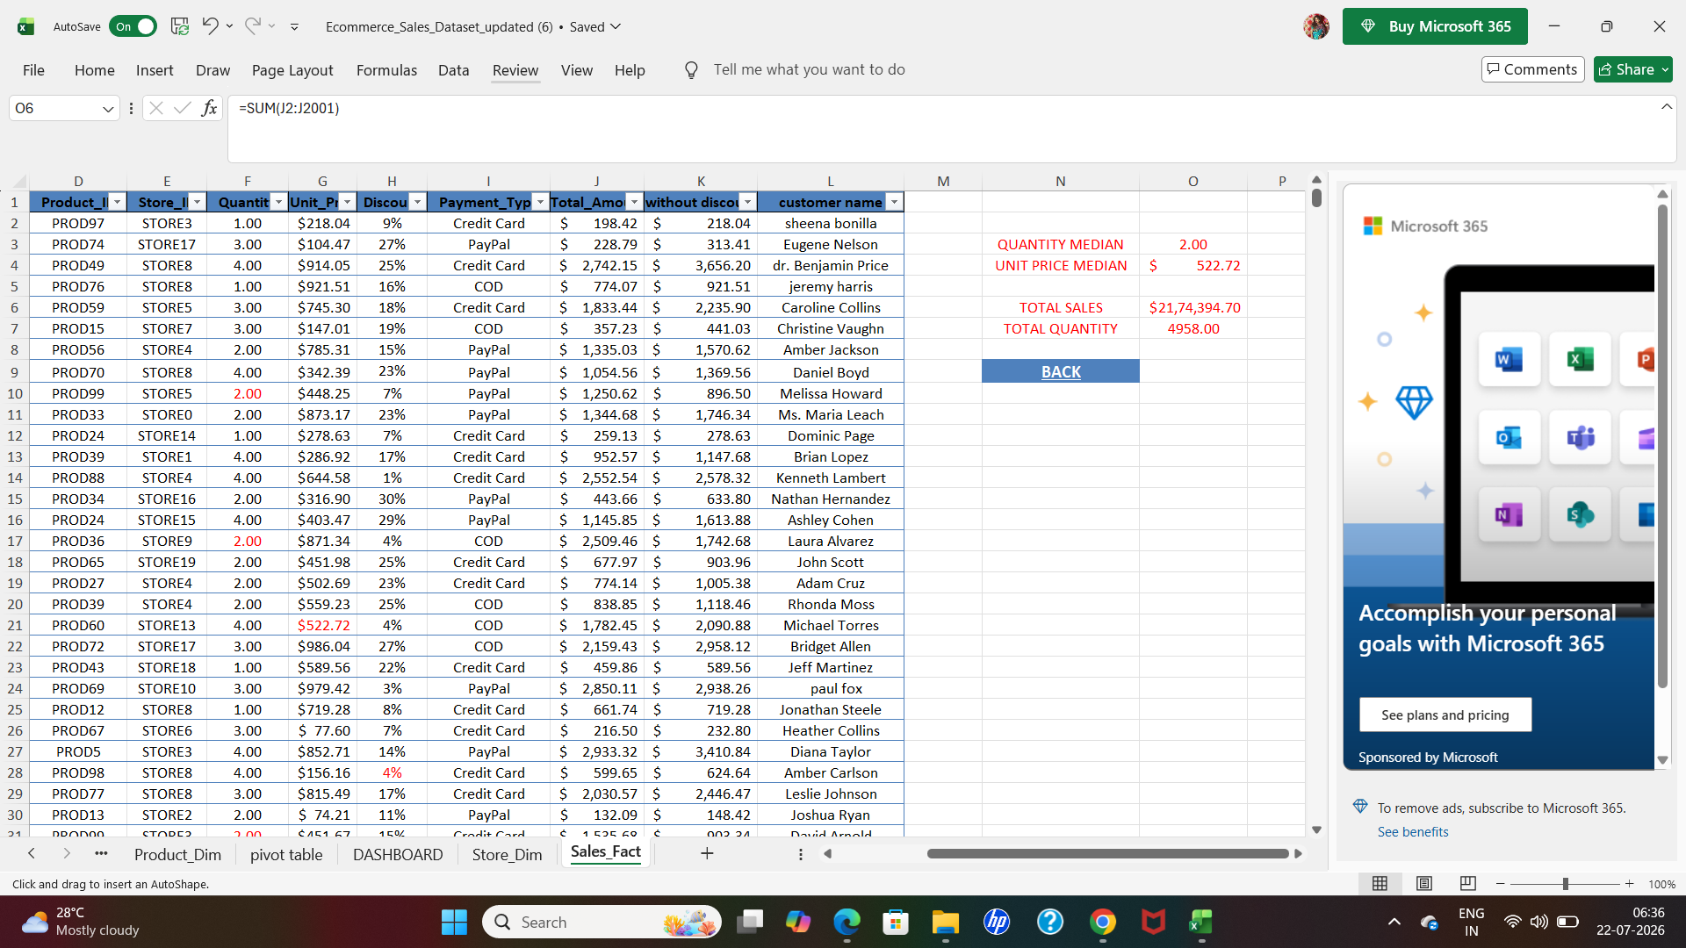

● Use the XLOOKUP/VLOOKUP functions to combine the tables.
SCREENSHOT-15
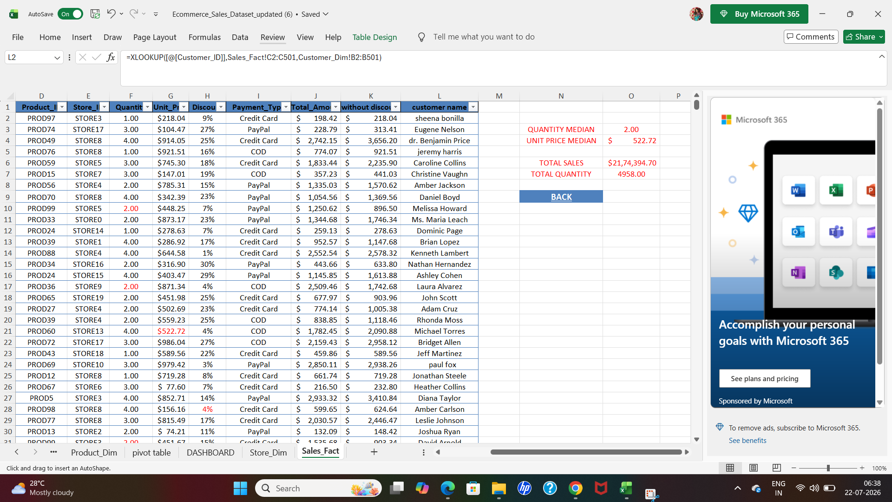

● Use of Pivot Tables for advanced summarization
SCREENSHOT-16
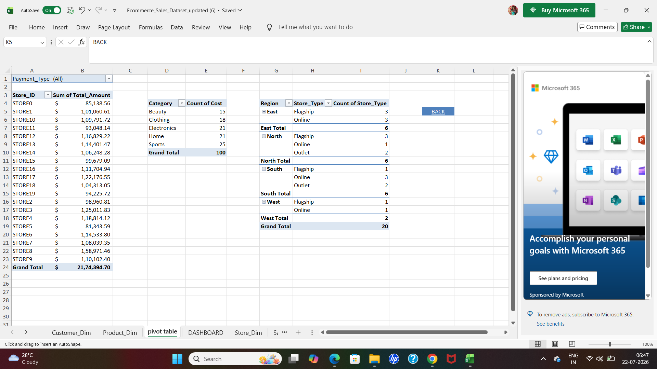

● Descriptive statistics (mean, median, mode, standard deviation, etc.) using formulas or
Analysis ToolPak
SCREENSHOT-17
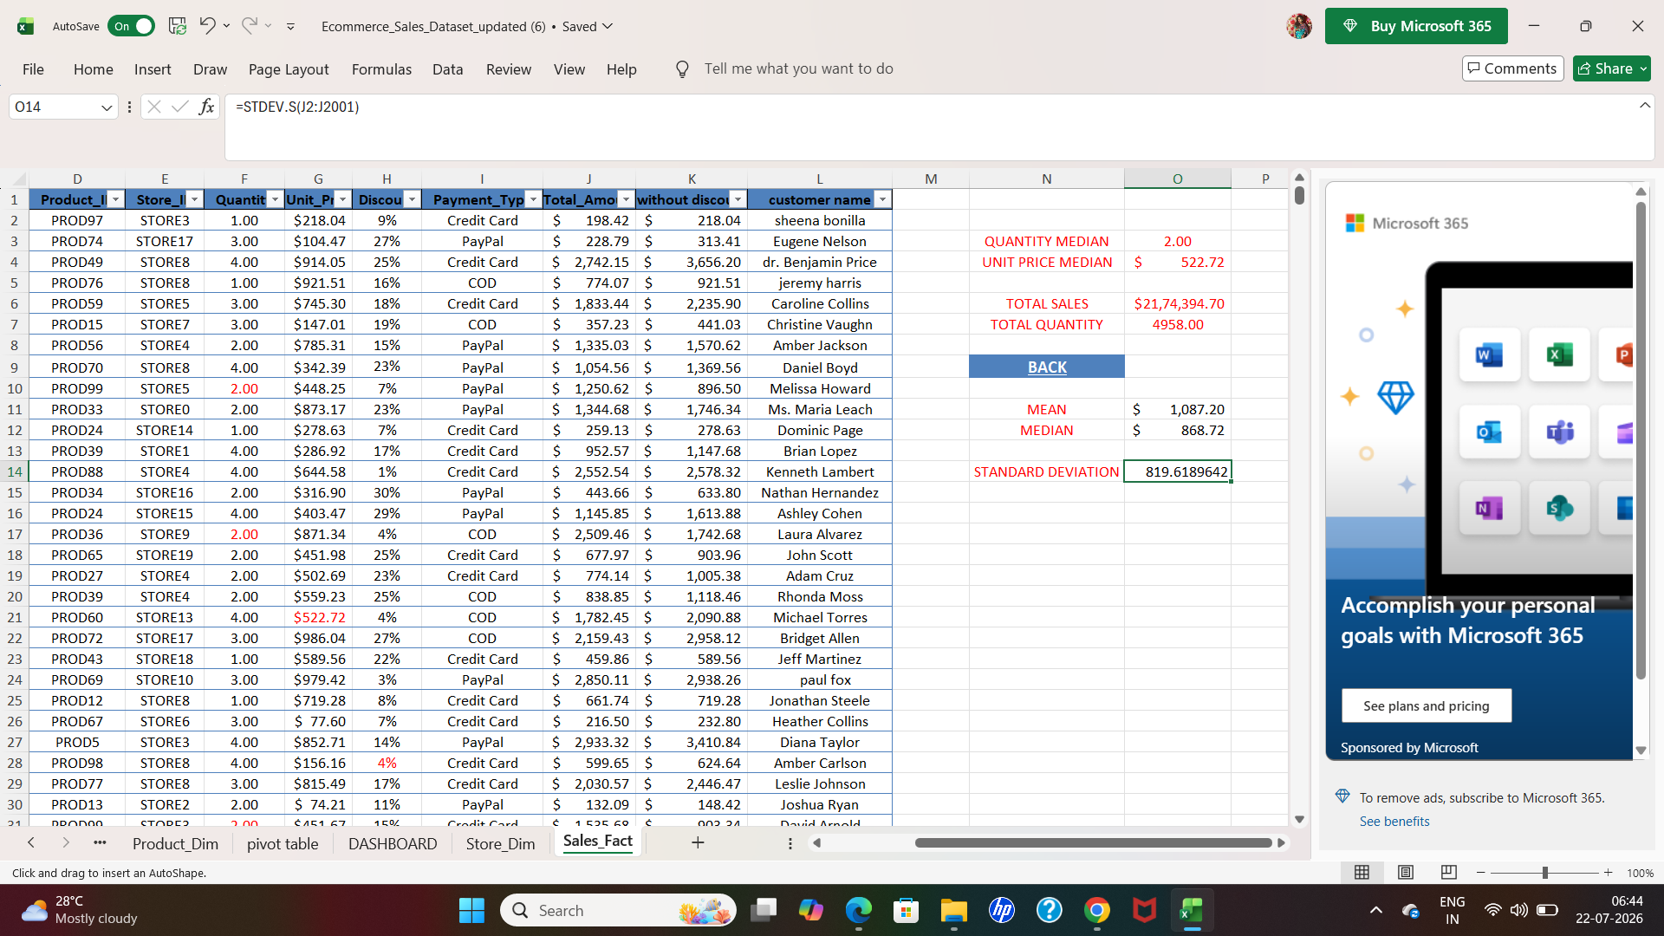

SCREENSHOT-18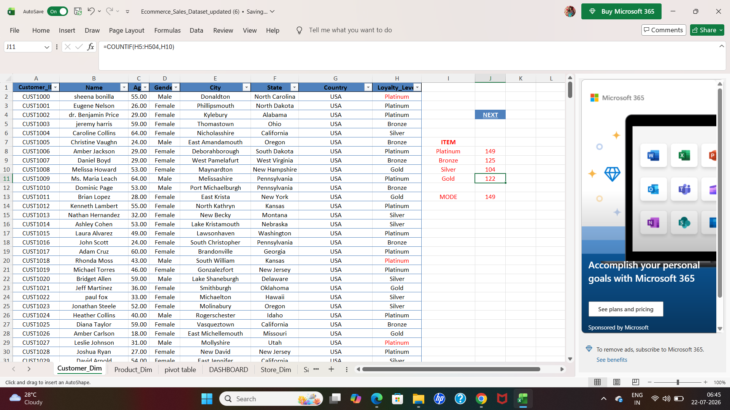

● Data visualization: create at least three chart types, build an interactive dashboard, and
use basic PivotCharts
SCREENSHOT-19
